**Team Knowledge**

Structure and Organization

*Team Demographics*

* *Team 13-0503 a.k.a. team EagleBotz*
* *11 people total*
  + *6 girls and 5 boys*
  + *two 11th graders, seven 9th graders ,two 8th graders*

*Meeting Process*

* *Afterschool-school programs on Mondays and Fridays from 3:30 until 5:00*
* *Near the end of the season, we began to meet on Wednesdays and Thursdays*

*Organization*

* *We have a team leader that helped wherever help was needed*
* *Everybody else divided into Coders and Builders, each group having a Coding head and Building Head respectfully*

Teamwork

*Decision Making Process*

* We sat down around a white board and listed all the goals that could be accomplished on the game board. Then we would pick the most important goals and find the steps we needed to do in order to succeed

*Handling Conflict*

* The team had small squabbles between members over designs and techniques for the robots. For example, one time two builders were arguing about the build of the arm that would be used to grab and lift the rocket boosters onto the launch pad support poles. In order to resolve this conflict, we told the two conflicting persons to write out the pros and cons to their own designs; this way they could find the design better suited to their purposes or compromise

*Change of Goals/Strategies (as time progressed)*

* Beginning: get everything done as early as possible such that everything and anything may be put under extreme testing to get the code and movement as close to perfect as possible
  + Original design for stacking robot: using a scissor lift and a series of gears to lift and stack
* End: Adjusted deadlines based on their priority to achieving points on the board
  + Changed design for stacking robot: using pulley system, linear slide, and unfolding mechanism to lift and stack

*Division of Labor*

* The coders and builders were divided into two approximately even groups based on their skill level; each group focusing on one robot with a list of things to do for their respective robot. Then, when a task was completed they would check in with their team leader

**Robot Design**

Description of overall robot system

*Overview*

* The Link can be broken into three basic actions
  + Pickup: using a series of gears, pom poms are transported into a “vacuum” (created by using a tread) which is moving by means of a single motor
  + Sort: at the top of this “vacuum” is a camera mounted on top with a turnstile below it. Thus, when the camera sees a pom pom, according to its color, the turnstile will move a specific direction to lead it into the corresponding basket that is found directly beside the “vacuum” on either side
  + Dump: When the pom poms land into their respective boxes, they gather and gather until the robot returns to where it must deposit the pom poms, then, using a mini servo and a rubber band the boxes are released and therefore dump the pom poms

*Sensor Support*

* The only sensor that is used on the Link for sorting the pom poms is the camera. This camera is mounted to a Lego piece via U-Glu and a screw found at the neck of the camera. Then, the lego piece attached to the camera is mounted to the top of the “vacuum” in a relatively secure way so that it does not fall off in the middle of the code

*Effector Support*

* The main effector on the link is the gear system that is meant to pull in the group of pom poms and break the groups such that each pom pom goes smoothly into the “vacuum” one by one. This gear system originates at the end of a wheel that is attached to the tread and follows a series of gears in order to lead the pom poms into the “vacuum”

*Testing*

* The different components of Link allow testing to be broken into the 3 basic actions that must be performed. Thus, we tested each part separately and then combined it together to form a single productive robot

*Tough Problem Encountered & Elegant Solution*

* Tough Problem Encountered: For the last basic action of dumping the pom poms, we encountered difficulty in finding a way to deposit the pom poms without making the containers too heavy/big and difficult to move
* Elegant Solution: When we encountered this problem, we decided to use our maximum amount of one piece of paper to hold the pom poms in. We decided to attach the paper to a simple base that could easily be flipped. In the end, we attached a mini-servo to the chassis and utilized an elastic band for a one time flip (which had been our intention)

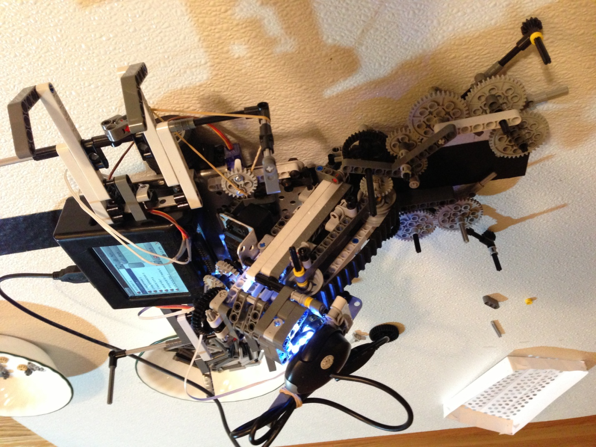

**Thank You Letter**

Dear Mrs. Powers and Mrs. Bandaru,

Thank you so much for committing so much time into helping us whenever we needed you. You did so much more than what was required of you, and we greatly appreciate you for that. The sacrifices you made to let us stay after school and work on this competition have not been forgotten and we deeply appreciate everything you have done for us. You did so much more than what was required of you, and we greatly appreciate everything. Your support is irreplaceable

Sincerely,

EagleBotz!